A PROJECT REPORT ON

The Forest Fire Early Warning System using AWS

SUBMITTED TO
MIT SCHOOL OF COMPUTING, LONI, PUNE IN PARTIAL FULFILLMENT OF THE REQUIREMENTS FOR THE Third Year MDM IoT Project
(12,upper case)
(Four blank spaces)

BY

(14, bold/upper case)
(Two blank spaces)
Candidate Name PRN/ Enrollment No:
Snehal Sukashe ADT23SESB0226
Prajwal Bahir ADT23SESB0215
Rohit Darode ADT23SESB0235
Akash Deshmukhe ADT23SESB0202

Under the guidance of
(One blank spaces)
(14/bold, upper case)
Dr. Megha Wankhade (Guide) & Dr. Pranav Chippalkatti (Co-Guide)
(one blank spaces)

(one blank spaces)
DEPARTMENT OF COMPUTER SCIENCE AND ENGINEERING

(Two blank spaces)
MIT School OF COMPUTING
MIT Art, Design and Technology University
Rajbaug Campus, Loni-Kalbhor, Pune 412201
(One blank spaces)
2025-26


MIT SCHOOL OF COMPUTING
DEPARTMENT OF COMPUTER SCIENCE AND ENGINEERING
MIT ART, DESIGN AND TECHNOLOGY UNIVERSITY,
RAJBAUG CAMPUS, LONI-KALBHOR, PUNE 412201
(16, bold, upper case)
(Two blank spaces)
CERTIFICATE
(16, bold, upper case)

(Two blank spaces)
This is to certify that the project report entitled (12, sentence case) (One blank space)
“The Forest Fire Early Warning System using AWS”
Submitted by
(One blank space)
Candidate Name PRN/ Enrollment No:
Snehal Sukashe ADT23SESB0226
Prajwal Bahir ADT23SESB0215
Rohit Darode ADT23SESB0235
Akash Deshmukhe ADT23SESB0202

is a bonafide work carried out by them under the supervision of Dr. Megha Wankhade (Guide) & Dr. Pranav Chippalkatti (Co-Guide) and it is submitted towards the partial fulfillment of the requirement of Third Year MDM IoT Project (12, Sentence case)
(Four blank spaces)

Dr. Pranav Chippalkatti Dr. Megha Wankhade
Co-Guide Guide

Place: PUNE
Date:

DECLARATION
(Three blank spaces)

We, the team members

Name | Enrollment No
Snehal Sukashe | ADT23SESB0226
Prajwal Bahir | ADT23SESB0215
Rohit Darode | ADT23SESB0235
Akash Deshmukhe | ADT23SESB0202
Hereby declare that the project work incorporated in the present project entitled “The Forest Fire Early Warning System using AWS” is original work. This work (in part or in full) has not been submitted to any University for the award or a Degree or a Diploma. We have properly acknowledged the material collected from secondary sources wherever required. We solely own the responsibility for the originality of the entire content.
Date: 03/11/2025

Snehal Babasaheb Sukashe Prajwal Ashok Bahir

Rohit Balasaheb Darode Akash Shantling Deshmukhe

Dr. Pranav Chippalkatti Dr. Megha Wankhade
Co-Guide Guide

Seal/Stamp of the College
Place: Pune
Date: 03/11/2025
(one blank spaces)
ACKNOWLEDGEMENT(16, bold/upper case)
(Three blank spaces)
We express our profound thanks to guide Dr. Megha Wankhade, Associate Professor, Department of Computer Science and Engineering (EEE) and Co-Guide Dr. Pranav Chippalkatti, Assistant Professor, Department of Computer Science and Engineering (EEE), MIT School of Computing, MIT-ADT University, Pune for their expert guidance, encouragement and inspiration during this project work.
We also express thanks to respected Prof. Dr. Rajesh S (Vice Chancellor, MIT ADT University), Prof. Dr. Ramchandra Pujeri (Pro-VC, Technology Cluster), Prof. Dr. Rajneeshkaur Sachdeo (Dean, MIT ADT University), Prof. Dr. Ganesh Pathak (Dean, MITSOC) for providing the facilities to carry out our work.
We also thank all the HODs and faculty members in the department for their support and advice. We are very much grateful to our parents for their immense love, affection, help, cooperation and encouragement to complete this project.
Finally, a special thanks to all our classmates and friends who helped and encouraged us for successful completion of our project work.

Snehal Sukashe ADT23SESB0226
Prajwal Bahir ADT23SESB0215
Rohit Darode ADT23SESB0235
Akash Deshmukhe ADT23SESB0202

(one blank spaces)
ABSTRACT(16, e)
(Three blank spaces)
Wildfires lead to severe environmental degradation and heavy economic losses each year. Detecting potential fire outbreaks at an early stage is crucial for reducing their destructive impact. This paper introduces a smart The Forest Fire Detection and Early Warning System built around the ESP32 microcontroller and Amazon Web Services (AWS) cloud platform. The system continuously collects real-time environmental data such as temperature, humidity, gas concentration, and flame intensity through DHT11, MQ-3, and flame sensors.
The ESP32 serves as the core processing unit, acquiring sensor data and transmitting it securely to AWS IoT Core using the MQTT communication protocol. This ensures reliable and low-latency data exchange between the hardware and the cloud. The collected data are analyzed on AWS, where defined threshold values help in identifying potential fire conditions. When any abnormal pattern or sudden rise in temperature, smoke, or flame intensity is detected, AWS Simple Notification Service (SNS) automatically triggers an alert. The alert, in the form of an email notification, is sent instantly to registered forest management authorities, enabling them to take timely preventive measures.
This integration of IoT and cloud technologies allows the system to function efficiently in remote forest areas, offering high scalability, low power consumption, and real-time monitoring capabilities. The proposed model not only minimizes the risk of widespread wildfire damage but also supports sustainable environmental management. With its flexibility and cost-effectiveness, the system can be expanded across multiple locations, creating a robust network for proactive disaster prevention. In conclusion, this IoT-based AWS-integrated fire detection system provides an intelligent, automated, and reliable solution for early wildfire detection and rapid emergency response.

CONTENTS

Certificate ………………....………………………….…………. | i
Declaration ……………….…………….………………....………. | ii
Examiner’s Approval Certificate …………………………………. | iii
Acknowledgement ……………….…………………..……………. | iv
Abstract …………………………………………..…...……………. | v
List of Figures ………………………..………….…………………. | vi
List of Tables ……………………….…………….…………………. | viii

Chapter 1 INTRODUCTION 1
1.1 Introduction 1
1.2 Need of Forest Fire Detection Systems 1
1.3 Problem Statement 1
1.4 Existing Work 2
1.5 Motivation 2
1.6 Objective 2
1.7 Scope 2
1.8 Closure 3
Chapter 2 CONCEPTS AND METHODS 4
2.1 Overview of IoT and Cloud-Based Monitoring 4
2.2 Working Principles of Sensors 4
2.2.1 DHT 11 4
2.2.2 MQ-3 Gas Sesnsor 5
2.2.3 Flame Sensor 5
2.2.4 OLED 5
2.3 AWS IoT Core and MQTT Connection 6
2.4 Email Alert System using AWS SNS 6
2.5 Closure 7
Chapter 3 LITERATURE SURVEY 8
3.1 Review of Existing Forest Fire DetectionSystems 8
3.2 Comparision with Proposed System 10
3.3 Research Gap Identified 11
3.4 Closure 12
Chapter 4 PROJECT PLAN 13
4.1 System Architecture and Design 13
4.2 Methodology and Workflow 13
4.3 Hardware and Software Requirements 15
4.4 Implementation Phases 16
4.5 Closure 17
Chapter 5 Hardware Implementaion ,Simultion ,and PCB Design 18
5.1 Overview 18
5.2 Hardware Components 18
5.3 Circuit Design and Connections 19
5.4 Simulation Results 20
5.5 PCB Design and Fabrication 20
5.6 Working of the System 20
5.7 Closure 21
Chapter 6 RESULTS and Discussion 22
6.1 Overview 22
6.2 Simulation Results 22
6.3 Hardware Testing and Results 22
6.4 Discussion 24
6.6 Closure 24
Chapter 7 Conclusion and Future Scope 26
7.1 Conclusion 26
7.2 Future Scope 27
7.3 Closure 27
BIBLIOGRAPHY 28
ANNEXURE A: COST SHEET 29
ANNEXURE B: Copyright Acknowledgement Slip 30
ANNEXURE C: Empathy Chart and Solution Document 31
Annexure D: Project Tracker

LIST OF FIGURES

Figure Number: Figure of the table Page Number

Figure 2.1: DHT 11
Figure 2.2: MQ-3 Gas Sensor
Figure 2.3: Flame sensor
Figure 2.4: OLED Display
Figure 2.5: Flow Diagram of MQTT Communication (Publisher–Broker–Subscriber Model)
Figure 2.6: AWS SNS Workflow Diagram
Figure 3.1: System Performance Comparison
Figure 3.2: Visual Flow of Identified Research Gaps and How the Proposed System Addresses Them
Figure 4.1: System Architecture
Figure 4.2: Methodology Workflow of the Forest Fire Early Warning System
Figure 5.1: Actual Prototype
Figure 5.2: Simulated circuit of the Forest Fire Detection and Email Alert System
Figure 5.3: PCB layout of the system
Figure 6.1: EMAIL RECEIVED

LIST OF TABLES

Table Number: Title of the table Page Number

Table 3:1: Literature Survey
Table 3:1: Hardware Requirements
Table 3:2: Software Requirements

(one blank spaces)

INTRODUCTION

1.1 Introduction
Forest fires are a growing environmental concern that cause severe ecological imbalance, property loss, and endanger human and animal lives. Rapid urbanization, deforestation, and rising global temperatures have made forests increasingly vulnerable to wildfires. Once ignited, these fires spread quickly, making early detection and timely intervention essential to reduce damage.
This project focuses on developing an IoT-based Forest Fire Detection and Early Warning System that utilizes modern sensor technology and cloud integration for real-time monitoring. The system is designed using an ESP32 microcontroller, combined with sensors such as DHT11, MQ-3, and a flame sensor to measure environmental conditions. Data from these sensors are transmitted to Amazon Web Services (AWS) IoT Core using the MQTT protocol, where abnormal readings trigger automated email alerts through AWS Simple Notification Service (SNS).
By integrating IoT and cloud technologies, this system ensures efficient data collection, quick response time, and remote monitoring capabilities—making it suitable for large forest regions where manual surveillance is challenging.

1.2 Need for Forest Fire Detection Systems

Traditional forest fire detection methods, such as satellite imagery or human watchtowers, often involve delays and depend heavily on favorable weather and visibility conditions. These limitations can result in fires being detected only after significant damage has occurred. An IoT-based system can overcome these issues by providing continuous, real-time monitoring and automatic alerting, ensuring that authorities receive immediate notifications of potential fire incidents.

1.3 Problem Statement

Forest fires endanger wildlife, forests, and communities, yet existing detection methods remain slow and unreliable. A real-time, intelligent early warning system is essential to reduce risks and prevent large-scale damage

.

1.4 Existing Work
Various studies have explored the use of wireless sensor networks and image processing for fire detection. While these systems can identify fire events, they often face challenges such as high power consumption, poor connectivity in remote areas, and limited scalability. Recent advancements in IoT and cloud platforms like AWS have made it possible to build more efficient and low-cost solutions that offer real-time monitoring and cloud-based alerting.

1.5 Motivation
The motivation behind this project stems from the urgent need to protect forests and wildlife from increasing wildfire incidents. By leveraging IoT and cloud technology, it is possible to build a smart, automated, and sustainable system that reduces manual monitoring efforts and improves the speed of emergency response. The system aligns with global goals for environmental conservation and disaster risk reduction.

1.6 Objectives
The main objectives of this project are:
- To design a real-time forest fire detection system using ESP8266 and multiple sensors.
- To monitor temperature, humidity, smoke, and flame levels continuously.
- To send instant alerts through AWS IoT Core and SNS when abnormal readings are detected.
- To create a low-cost and reliable solution for early forest fire warning and prevention.

1.7 Scope
The proposed system can be deployed in forest regions, wildlife reserves, or other sensitive ecological zones to monitor environmental changes in real time. It provides an automated early warning mechanism without requiring constant human supervision. The design is modular, allowing additional sensors or AI-based analytics to be added in the future for improved prediction accuracy. The approach can also be adapted for other disaster management applications, such as flood or air quality monitoring.

1.8 Closure
In conclusion, this chapter has outlined the need, motivation, and objectives behind developing an IoT-base forest fire detection system using AWS and ESP32. The integration of sensors, cloud computing, and real-time alerts creates a smart framework for proactive disaster prevention. The proposed system bridges the gap between conventional fire monitoring and modern automation, offering a reliable and scalable solution to safeguard forest ecosystems.
The following chapters will discuss the concepts, methodologies, system architecture, implementation, and results that demonstrate the system’s effectiveness in early fire detection and rapid alert generation.

Chapter 2 CONCEPTS AND METHODS(one blank spaces)
2.1 Overview of IoT and Cloud-Based Monitoring
The Internet of Things (IoT) refers to a network of interconnected devices that collect, process, and exchange data through the internet without direct human intervention. In the context of forest fire detection, IoT technology enables the deployment of multiple environmental sensors that continuously monitor surrounding conditions such as temperature, humidity, gas concentration, and flame presence.
The data from these sensors are collected by the ESP32 microcontroller, which acts as the processing and communication unit. Using a cloud-based platform like Amazon Web Services (AWS), the data can be transmitted, analyzed, and stored remotely. Cloud computing ensures real-time accessibility, scalability, and data security while minimizing local storage requirements.
This integration of IoT and cloud technologies allows authorities to monitor vast forest regions remotely, visualize environmental trends, and take timely action in case of anomalies.

2.2 Working Principle of Sensors (DHT11, MQ-3, Flame Sensor)

2.2.1 DHT11 Sensor
The DHT11 sensor measures temperature and humidity. It contains a thermistor for temperature sensing and a capacitive humidity sensor for moisture detection. The sensor outputs calibrated digital data, which is read by the ESP32. High temperature and low humidity readings often indicate potential fire conditions.
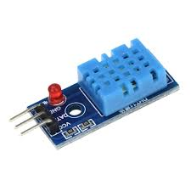
Fig 2.1 DHT11

2.2.2 MQ-3 Gas Sensor
The MQ-3 sensor is used to detect the presence of combustible gases and smoke in the environment. It operates on the principle of change in resistance of the sensing element (SnO₂) when exposed to gases such as carbon monoxide or ethanol. A sudden increase in gas concentration is a strong indicator of fire or combustion activity.
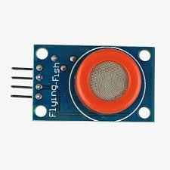
Fig2.2 MQ-3 Gas Sensor
2.2.3 Flame Sensor
The flame sensor detects fire or flame presence based on infrared (IR) radiation emitted by flames. It uses a photodiode that responds to IR wavelengths typically between 760 nm and 1100 nm. The sensor outputs a digital HIGH signal when a flame is detected, allowing immediate fire recognition by the ESP32.
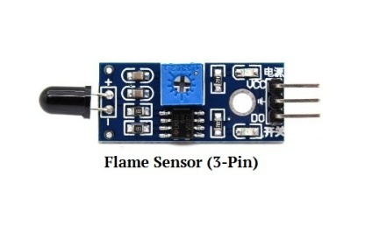
Fig 2.3 Flame Sensor
2.2.4 OLED
The OLED display is a self-emissive screen that produces light using organic compounds when an electric current passes through them. It operates without a backlight, offering high contrast, wide viewing angles, and low power consumption. The SSD1306-based OLED module communicates with the ESP32 via the I²C interface (SDA and SCL lines), enabling efficient data transmission. It displays real-time sensor readings such as temperature, humidity, gas concentration, and flame detection status, allowing users to visually monitor environmental conditions instantly.`
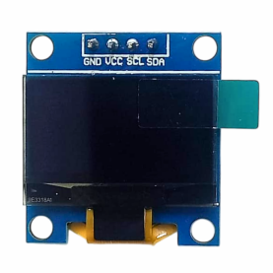
Fig 2.4 OLED Display

2.3 AWS IoT Core and MQTT Communication
AWS IoT Core is a managed cloud service that allows IoT devices to connect securely to the AWS cloud and exchange data. It provides a reliable bridge between physical devices and cloud-based applications.
The communication between the ESP32 and AWS IoT Core is established using the Message Queuing Telemetry Transport (MQTT) protocol—a lightweight and efficient publish-subscribe messaging protocol ideal for IoT environments.
- The ESP32 acts as a publisher, sending sensor data to the MQTT topic on AWS IoT Core.
- AWS IoT Core acts as a broker, managing the data flow.
- The subscriber (in this case SNS) processes the data and triggers alerts if thresholds are exceeded.
This architecture ensures real-time data transmission and low power consumption, even in remote forest areas with limited connectivity.
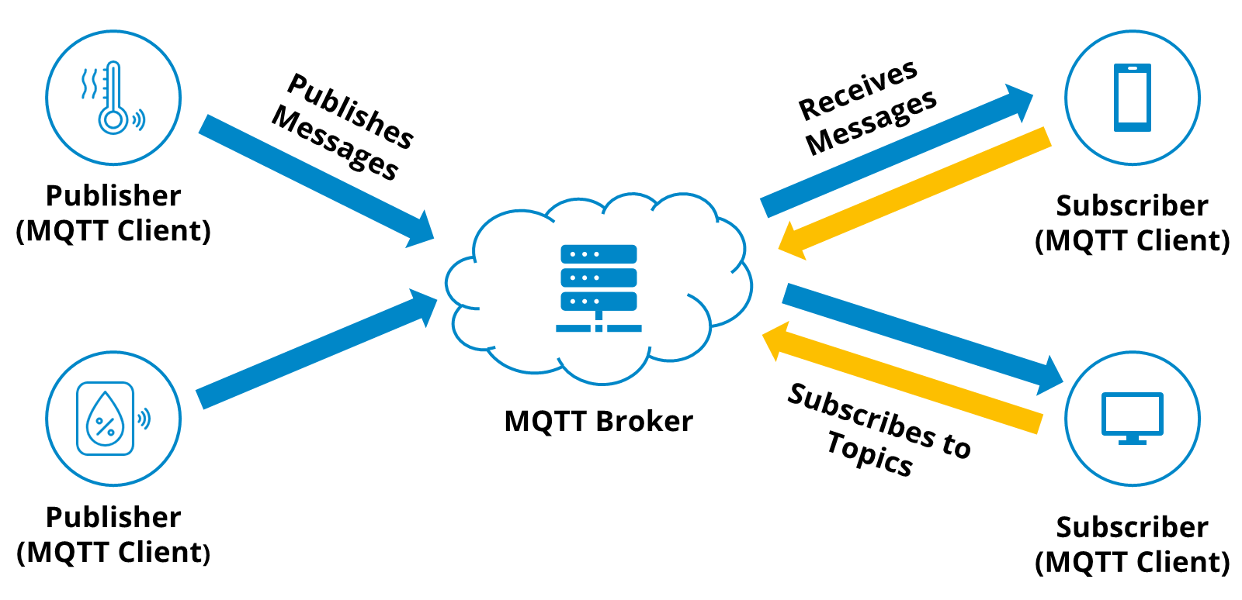
Fig 2.5 Flow Diagram of MQTT Communication (Publisher–Broker–Subscriber Model)

2.4 Email Alert System using AWS SNS
The Amazon Simple Notification Service (SNS) is a fully managed messaging service that sends notifications via email, SMS, or other endpoints. In this project, AWS SNS is configured to send email alerts to registered users whenever fire-related parameters cross predefined thresholds.
The process involves the following steps:
- The ESP32 collects sensor data and publishes it to AWS IoT Core.
- A rule in AWS IoT Core checks for abnormal conditions (e.g., temperature > 45°C, gas > threshold, flame detected).
- If the condition is true, the rule triggers an SNS topic.
- SNS instantly sends an email alert to the subscribed recipients, notifying them of a possible fire event.
This automated notification mechanism ensures that authorities can respond immediately, minimizing fire spread and damage.
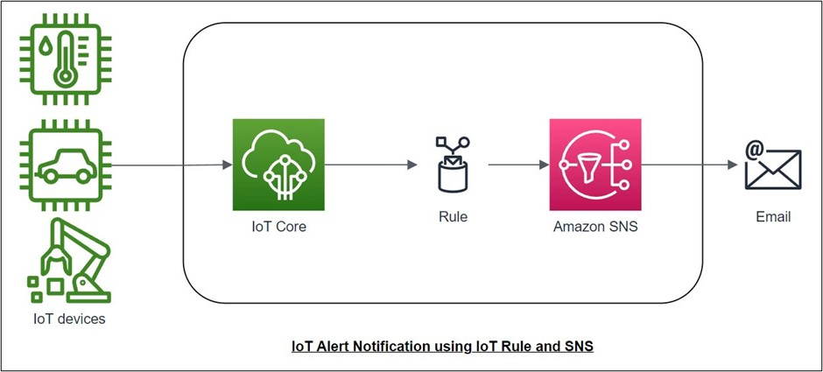

Fig 2.6 AWS SNS Workflow Diagram

2.5 Closure
This chapter described the core concepts and technologies behind the IoT-based Forest Fire Detection System. It explained how IoT and cloud integration enable real-time environmental monitoring, discussed the working principles of key sensors, and outlined the communication and alert mechanisms using AWS IoT Core, MQTT, and SNS.

Chapter 3 LITERATURE SURVEY

3.1 Review of Existing Forest Fire Detection Systems
In recent years, several research efforts have explored the use of IoT, cloud computing, and embedded systems to develop efficient and scalable forest fire detection systems. The review of existing literature provides a foundation for understanding the technological advancements and design strategies that have influenced the development of the proposed system.
One notable work titled “ESP32-Based Intelligent Fire Detection System Utilizing Machine Learning and Computer Vision for Enhanced Safety” presents a hybrid approach combining multiple sensors with machine learning algorithms and computer vision. This system uses the ESP32 microcontroller and MQTT communication protocol for transmitting real-time sensor data to the cloud. The paper highlights the use of sensor fusion and edge analytics to minimize false alarms, an idea that inspired the cloud-edge integration approach in our proposed work.
The second study, “Automatic Fire Detection in Forest by Enabling IoT,” describes a wireless sensor network (WSN) that integrates DHT11 and MQ7 sensors along with ESP32 for monitoring temperature, humidity, and gas levels. The system also uses the Blynk cloud platform and GPS (NEO-6M) for location tracking and alert notifications. The emphasis on early detection and low-cost scalability aligns closely with our project’s goals and motivated the choice of a similar sensor combination and threshold-based alerting.
In “IoT-Based Fire Safety System Using MQTT Communication,” the authors focus on the reliability and scalability of the MQTT protocol, which ensures efficient, low-latency data transfer between IoT devices and the cloud. Their findings validate our decision to use MQTT with AWS IoT Core for secure and continuous data transmission, ensuring real-time event updates.
The AWS technical blog post titled “Early Fire Detection Design Model for Smart Cities Using AWS IoT and ML Technologies” demonstrates how AWS IoT Core, Rules Engine, and Simple Notification Service (SNS) can be used together for intelligent, cloud-driven early warning systems. The architecture described in this article directly influenced the alert mechanism used in our prototype, which employs AWS IoT Core for message routing and SNS for sending automated email notifications.
Lastly, the study “IoT Enabled Advanced Forest Fire Detecting and Monitoring System” presents a multi-sensor setup using ESP32, DHT11, flame, and smoke sensors, integrated with cloud platforms for real-time monitoring and visualization. This research underscores the importance of data visualization dashboards and continuous parameter monitoring, both of which have been incorporated into our system’s design.
Sl. No. | Research Paper Title | Technology Used | Communication Protocol | Cloud Platform | Unique Features
1 | ESP32-Based Intelligent Fire Detection System Utilizing Machine Learning and Computer Vision for Enhanced Safety | ESP32, multiple sensors, machine learning, computer vision | MQTT | Custom cloud integration | Uses sensor fusion and edge analytics to reduce false alarms; introduces hybrid ML and vision-based detection
2 | Automatic Fire Detection in Forest by Enabling IoT | ESP32, DHT11, MQ7, GPS (NEO-6M) | Not specified (IoT-based WSN) | Blynk Cloud | Focuses on early detection, real-time GPS tracking, and low-cost scalability
3 | IoT-Based Fire Safety System Using MQTT Communication | IoT nodes, sensors, microcontrollers | MQTT | Not specified | Demonstrates reliability and scalability of MQTT for real-time fire safety alerts
4 | Early Fire Detection Design Model for Smart Cities Using AWS IoT and ML Technologies | AWS IoT Core, Rules Engine, SNS, ML models | MQTT | AWS IoT Core, SNS | Implements intelligent alert routing with AWS; automates notifications via email and SMS
5 | IoT Enabled Advanced Forest Fire Detecting and Monitoring System | ESP32, DHT11, flame sensor, smoke sensor | Not specified | Cloud-based dashboard | Real-time monitoring and data visualization; multi-sensor integration for improved accuracy

Table 3.1 Comparative Analysis of Existing Research Papers on IoT-Based Fire Detection Systems

3.2 Comparison with Proposed System
From the reviewed studies, it is evident that most existing systems aim to enhance early fire detection through IoT-enabled sensor networks and real-time communication. However, many systems rely on third-party mobile platforms or localized applications, which limit scalability and long-term data storage.
The proposed system differs by implementing a cloud-native approach using AWS IoT Core, which provides secure device authentication, scalable data handling, and automated notifications through SNS. While previous works demonstrated fire detection through temperature and gas readings, our design integrates three key sensors (DHT11, MQ-3, Flame Sensor) for multi-parameter sensing, improving detection accuracy. Additionally, AWS’s serverless architecture minimizes maintenance overhead while ensuring real-time alerts without manual intervention.

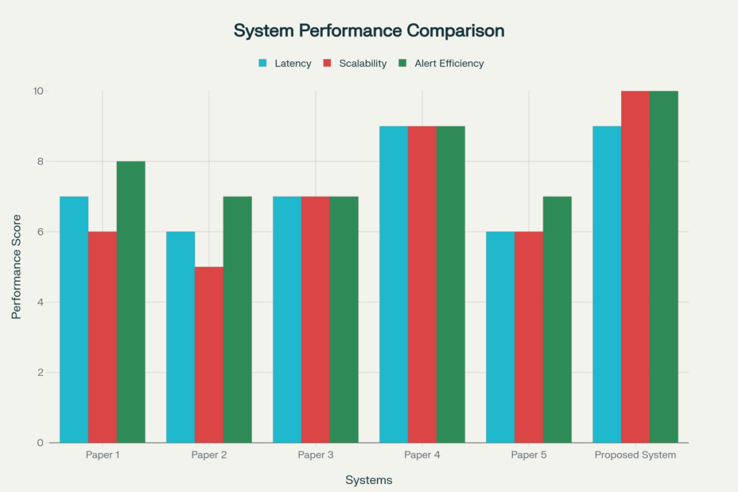
Fig 3.1 System Performance Comparision

3.3 Research Gap Identified
A detailed review of existing literature reveals certain limitations and opportunities for enhancement:
- Limited Cloud Integration: Most existing systems use mobile-based or small-scale cloud solutions (e.g., Blynk, ThingSpeak), lacking advanced rule-based automation and scalability.
- Lack of Unified Notification Mechanisms: Many systems do not employ a robust alert mechanism like AWS SNS, leading to delays in critical communication.
- Partial Sensor Utilization: While several projects use temperature or gas sensors individually, few combine temperature, humidity, gas concentration, and flame detection for comprehensive fire detection.
- Data Analytics and Edge Processing: Some studies highlight machine learning but lack cloud-edge synergy, which can optimize decision-making and reduce false alarms.
- Scalability and Remote Accessibility: Many earlier prototypes are limited to short-range communication without large-scale deployment potential.
To address these gaps, the proposed system combines multi-sensor IoT monitoring, AWS IoT Core for secure cloud connectivity, MQTT for efficient data transmission, and SNS for automated alerts. This integration ensures high reliability, low power consumption, and scalability suitable for real-world forest enviroment.
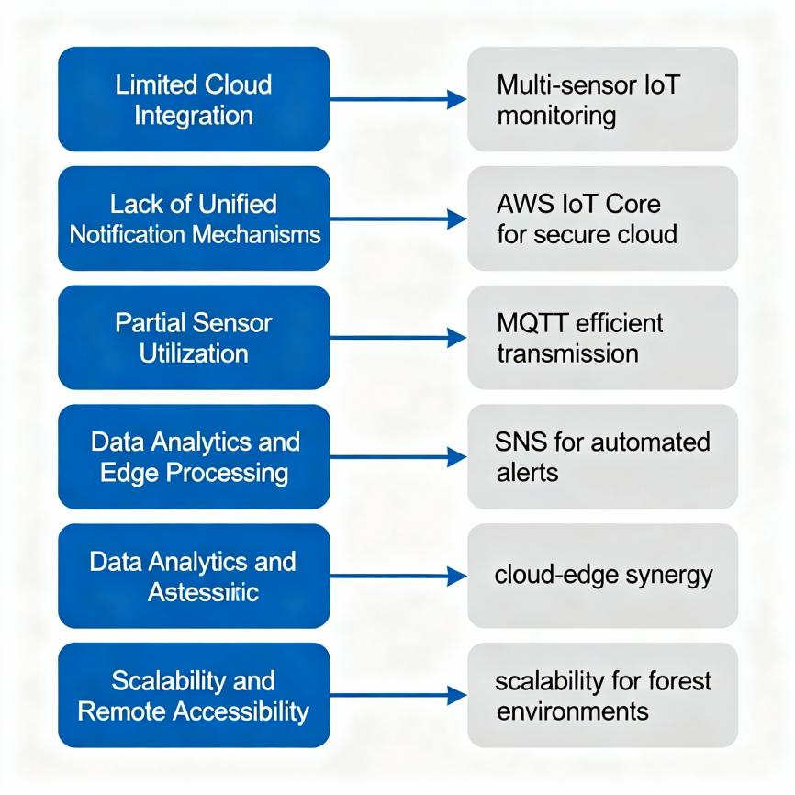
Fig 3.2 Visual Flow of Identified Research Gaps and How the Proposed System Addresses Them

3.4 Closure
This chapter presented an extensive review of related works in IoT-based fire detection systems and discussed how each contributes to the existing knowledge base. The comparison highlights that while prior studies made significant progress in early fire detection, the integration of AWS-based automation and real-time alerting remains underexplored. The identified research gaps guided the design and development of the proposed system, focusing on reliability, efficiency, and scalability for large-scale environmental monitoring.

Chapter 4: PROJECT PLAN

  - System Architecture and Design
The IoT-based Forest Fire Detection and Early Warning System is designed to detect abnormal environmental conditions that indicate potential fire incidents and send real-time alerts through the cloud. The system architecture consists of four main components: sensors, microcontroller, cloud platform, and alert system.
- Sensor Layer: Includes the DHT11, MQ-3, and Flame Sensor. These sensors continuously monitor temperature, humidity, gas concentration, and flame presence.
- Processing Layer: The ESP32 microcontroller serves as the central processing unit. It collects sensor data, processes readings, and communicates with the AWS cloud using the MQTT protocol.
- Cloud Layer: AWS IoT Core acts as the bridge between hardware and the internet. Data sent to AWS is analyzed in real-time, and rules are applied to identify abnormal conditions.
- Alert Layer: When thresholds are exceeded, AWS Simple Notification Service (SNS) sends email alerts to registered users, enabling quick response.
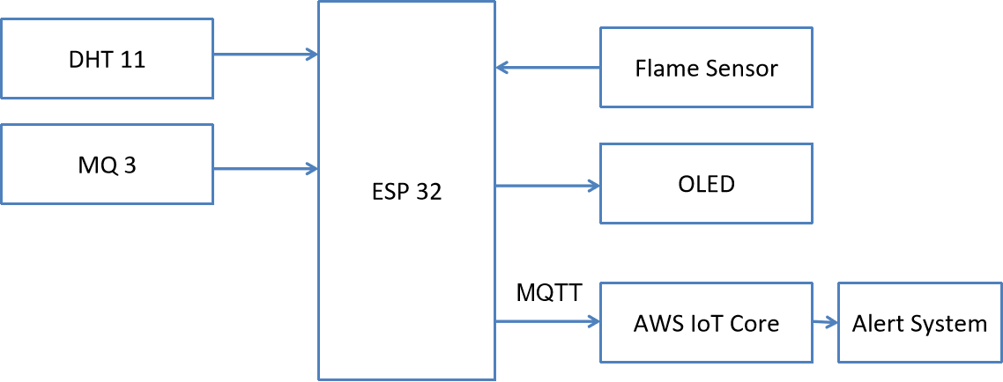Fig 4.1 System Architecture

4.2 Methodology and Workflow
The methodology adopted for developing the Forest Fire Early Warning System using AWS follows a structured workflow, as illustrated in Figure 4.2. Each stage ensures reliable data collection, cloud integration, and alert generation for effective forest fire detection.

Step 1: Sensor Integration
Multiple sensors such as DHT11 (temperature & humidity), MQ-3 (gas/smoke), and flame sensors are interfaced with the ESP32 microcontroller. This enables environmental parameter monitoring essential for early fire detection.

Step 2: Firmware Initialization
The ESP32 firmware is programmed using the Arduino IDE. It initializes sensor communication, establishes Wi-Fi connectivity, and sets up MQTT protocols for cloud data transmission.

Step 3: Data Acquisition
Sensor data is periodically read and filtered. The ESP32 sends these readings to the AWS IoT Core for storage and further analysis through MQTT communication.

Step 4: Threshold Evaluation
Predefined threshold values are used to identify abnormal temperature, humidity, or gas concentration levels. If readings exceed these limits, the system flags a potential fire event.

Step 5: Alert Delivery
Once a potential fire condition is detected, an alert is published via the AWS Simple Notification Service (SNS). Email or SMS notifications are sent to registered users for immediate action.

Step 6: Monitoring and Response
The AWS dashboard continuously monitors real-time data, providing visualization and historical trends. This allows rapid decision-making and response during emergencies.

Step 7: Setup and Deployment
The final step involves deploying the hardware system in the forest area. Calibration and testing are conducted to ensure accurate detection and reliable network connectivity.
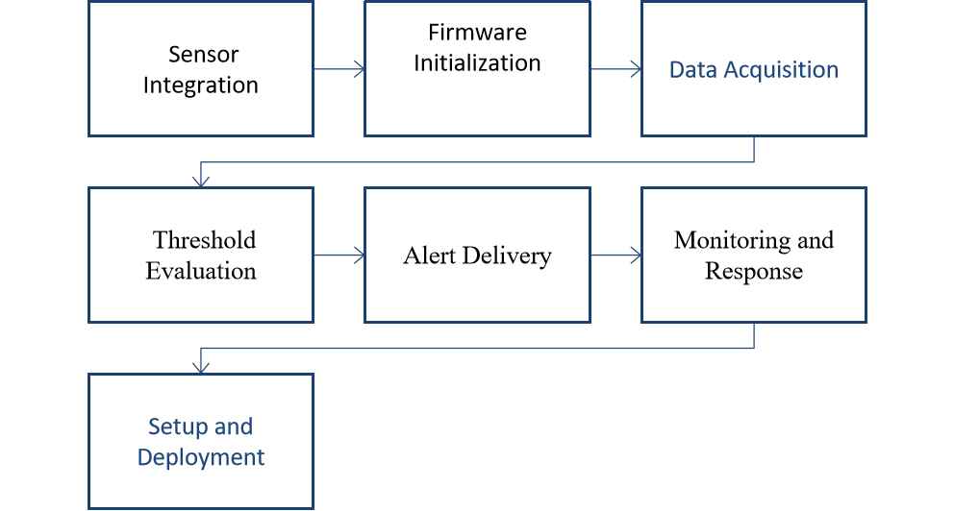
Fig 4.2 Methodology Workflow of the Forest Fire Early Warning System

Hardware and Software Requirements
Hardware Requirements
Component | Description | Quantity
ESP32 Microcontroller | 32-bit dual-core processor with Wi-Fi and Bluetooth connectivity | 1
DHT11 Sensor | Measures temperature and humidity | 1
MQ-3 Sensor | Detects smoke and flammable gases | 1
Flame Sensor | Detects infrared light from fire sources | 1
OLED Display | Displays live readings on-screen | 1
Power Supply | 3.3V–5V regulated DC supply | 1
Connecting Wires & Breadboard | For circuit interfacing | -
Table 4.1 Hardware Requirements
Software Requirements
Software | Purpose
Arduino IDE | Programming and uploading code to ESP32
AWS IoT Core | Cloud platform for IoT device communication
AWS SNS | Service for automated email alerts
MQTT Protocol | Communication protocol between ESP32 and AWS
Wi-Fi Network | Required for ESP32 cloud connectivity
Table 4.2 Software Requirements

This combination of hardware and software ensures the project’s efficiency, scalability, and compatibility with future upgrades.
  - Implementation Phases
The development process is divided into several phases to ensure systematic progress and successful completion:
- Phase 1 – Research and Study:
Conducted background research on forest fire detection methods, IoT applications, and AWS integration to define project scope and objectives.
- Phase 2 – Hardware Setup:
Interfaced sensors (DHT11, MQ-3, Flame Sensor) with ESP32 and verified data readings through serial monitoring.
- Phase 3 – Cloud Configuration:
Created and configured AWS IoT Core, generated security certificates, and established MQTT communication between ESP32 and AWS.
- Phase 4 – Alert Integration:
Configured AWS SNS to send email notifications when sensor readings exceeded the predefined threshold limits.
- Phase 5 – Testing and Validation:
Conducted multiple tests to ensure reliable data transmission, accurate readings, and timely alert generation.
- Phase 6 – Documentation and Analysis:
Collected all data, analyzed results, and documented project findings for reporting and demonstration.
4.4 Closure
This chapter presented the detailed planning, system architecture, workflow, and implementation phases of the project. The combination of IoT hardware, cloud-based analytics, and automated alerting provides an efficient and reliable framework for early forest fire detection and warning.

Chapter 5 HARDWARE IMPLEMENTATION, SIMULATION, AND PCB DESIGN
  - Overview
This chapter explains the practical realization of the Forest Fire Early Warning System using ESP32. It covers hardware implementation, circuit simulation, and PCB design. The system was first designed and tested in simulation software to verify circuit behavior before physical assembly and testing.
5.2 Hardware Components
- ESP32 Microcontroller:
Serves as the core controller, handling sensor data acquisition, decision-making, and cloud communication.
- Flame Sensor:
Detects the infrared radiation emitted by flames, outputting a digital HIGH signal when a fire is detected.
- DHT11 Sensor:
Measures ambient temperature and humidity to detect abnormal environmental changes.
- MQ-3 Gas Sensor:
Monitors the presence of smoke and combustible gases such as carbon monoxide (CO) and methane (CH₄).
- OLED Display (SSD1306):
Displays real-time sensor values and system status, aiding local monitoring.
- Power Supply Unit:
Provides a stable 5V DC power source through USB or an external regulated adapter.
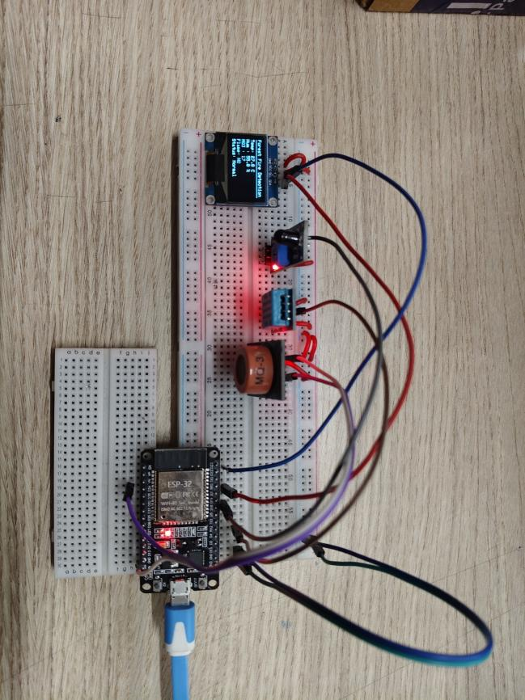
Fig 5.1 Actual Prototype
5.3 Circuit Design and Connections
The complete circuit for the Forest Fire Early Warning System using ESP32 was designed and simulated using CktDesignerIDE, an online circuit simulation platform that allows real-time testing of electronic circuits before physical implementation. This simulation environment helped verify the correctness of sensor interfacing, power distribution, and data communication between modules.
In the simulated setup, all sensors were connected to the ESP32 microcontroller, which served as the central unit for data acquisition and processing. The OLED display was interfaced through the I²C communication protocol, using the SDA and SCL lines for serial data transfer. Each sensor was assigned to a specific GPIO pin for efficient data handling and monitoring.
- The DHT11 temperature and humidity sensor was connected to Digital Pin 4, providing calibrated digital outputs for environmental monitoring.
- The MQ-3 gas sensor was connected to Analog Pin 34, allowing the ESP32’s ADC to measure varying gas concentrations.
- The Flame sensor was connected to Digital Pin 2, producing a HIGH logic signal when infrared radiation from a flame was detected.
- The OLED display used the I²C interface with SDA connected to GPIO 21 and SCL connected to GPIO 22, enabling efficient two-wire communication for real-time data visualization.
The circuit also included a regulated 5 V DC power supply, ensuring stable operation of all components. Proper grounding was maintained throughout the system to minimize electrical noise and improve sensor accuracy. The ESP32’s onboard voltage regulator provided 3.3 V to sensors that required lower operating voltages.
Simulation in CktDesignerIDE confirmed the logical operation of all components. Sensor outputs were observed on the virtual terminals, and the OLED display accurately presented temperature, humidity, gas concentration, and flame detection status. The simulation stage was crucial for debugging pin configurations, verifying voltage levels, and ensuring that the system would perform reliably during real-world hardware testing.
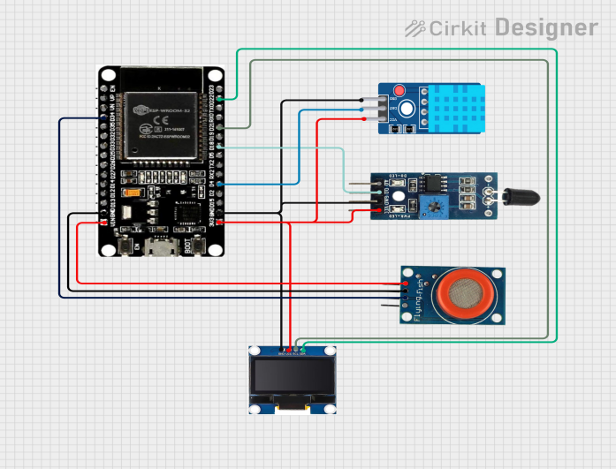
Fig 5.2 Simulated circuit of the Forest Fire Detection and Email Alert System.

5.4 Simulation Results
The simulated circuit verified that all sensors responded correctly to input variations.
- Flame detection triggered a digital HIGH output.
- Increasing gas concentration caused proportional analog output changes from MQ-3.
- The OLED displayed temperature, humidity, and gas data dynamically.
The successful simulation confirmed that the design was ready for hardware implementation.
5.5 PCB Design and Fabrication
After validation in simulation, a Printed Circuit Board (PCB) layout was designed using EasyEDA software.
- The PCB was designed with proper trace widths, grounding, and component placement to minimize noise.
- The ESP32 and sensors were mounted on a single-layer PCB for compactness.
- Female headers were used for modular connections.
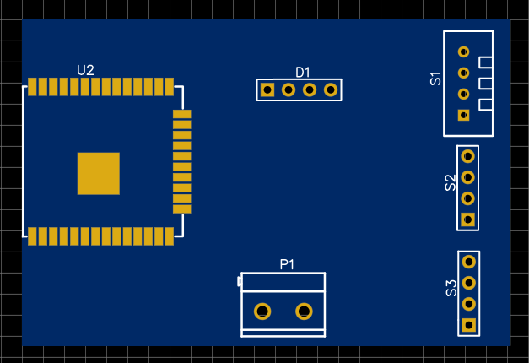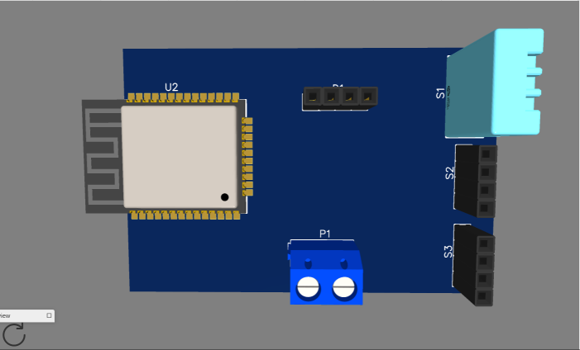
Fig 5.3. PCB layout of the system.
5.6 Working of the System
- Sensors continuously monitor environmental parameters (temperature, humidity, gas, and flame).
- ESP32 processes the sensor data and checks for threshold exceedance.
- If a potential fire condition is detected, an alert is generated:
- OLED displays “Fire Detected!” message.
- Data is uploaded to AWS IoT Core via MQTT.
- AWS SNS sends an email alert to the user.
- The system resets automatically when conditions return to normal.

5.7 Closure
This chapter detailed the step-by-step development of the hardware prototype, including circuit simulation, PCB fabrication, and integration. The simulation verified system performance, while the PCB ensured reliable and compact implementation. The hardware worked efficiently for fire detection and real-time IoT-based monitoring.

Chapter 6: Results and Discussion
  - Overview
This chapter presents the outcomes of both the simulation and hardware implementation of the Forest Fire Early Warning System using ESP32. The system’s performance was evaluated under various test conditions to verify sensor accuracy, data transmission reliability, and overall response time. The results confirm the system’s effectiveness in detecting early signs of forest fires and sending timely alerts through cloud communication.

6.2 Simulation Results
The simulation was performed using CktDesignerIDE to validate circuit connectivity and component behavior before hardware assembly.
During simulation
- The DHT11 sensor provided accurate temperature and humidity readings.
- The MQ-3 gas sensor showed analog voltage variations corresponding to changes in gas concentration.
- The Flame sensor generated a digital HIGH signal when exposed to an IR light source, simulating a flame condition.
- The OLED display dynamically showed all sensor values in real-time, confirming proper I²C communication with the ESP32.
The simulation confirmed correct logical functioning of the system, validating that sensor readings, threshold detection, and display output worked as expected.

6.3 Hardware Testing and Results
After successful simulation, the circuit was implemented on a custom-designed PCB. Each sensor module was interfaced with the ESP32, and the OLED display provided continuous feedback of environmental parameters. The prototype was tested under different environmental conditions:

Case 1: Normal Condition
- Temperature: 28–32°C
- Humidity: 55–65%
- MQ-3 Reading: 150–200
- Flame: NO
- OLED Status: “Normal”
- AWS Cloud: Regular telemetry updates every 10 seconds.
- Email Alerts: None triggered.
Case 2: Smoke or Gas Presence
When smoke was introduced near the MQ-3 sensor:
- MQ-3 Reading spiked to 450–550
- OLED Display:
- LED Blinked 10 times.
- AWS IoT published an alert message:
{
"ts": 621084,
"alert": "SMOKE: 482",
"temperature": 31.8,
"humidity": 57.2,
"mq3": 482,
"flame": false
}
Email Notification via AWS SNS received within 3–5 seconds.

Case 3: Flame Detected
When a lighter flame was introduced near the flame sensor:
Flame sensor output → LOW (active state).
OLED Display:
Temp: 45.3°C Hum : 40.1% MQ3 : 710 Flame: YES Status: FLAME DETECTED!
LED blinked rapidly to indicate danger.
AWS IoT published alert message:
{
"ts": 625413,
"alert": "FLAME DETECTED!",
"temperature": 45.3,
"humidity": 40.1,
"mq3": 710,
"flame": true}
Email alert with subject “FIRE DETECTED: ESP32 Forest Monitor” received within 5 seconds.
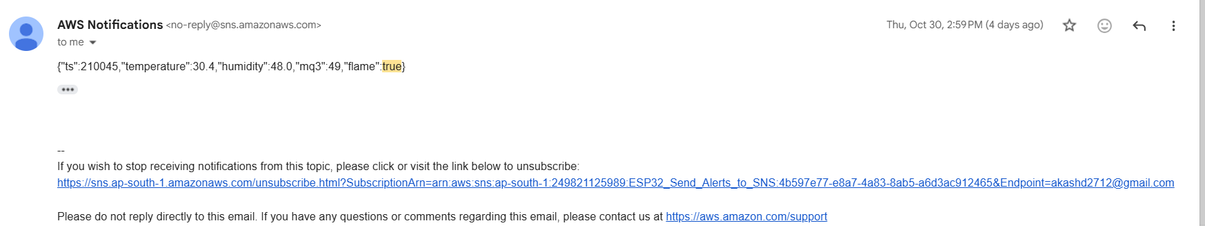
Fig 6.1 Email Received
6.5 Discussion
The system functioned reliably in both simulation and hardware testing. The OLED provided clear and accurate sensor readings, while AWS IoT enabled secure real-time monitoring.
- The response time from detection to cloud alert was around 2–3 seconds.
- The OLED display refreshed smoothly without lag.
- The MQ-3 was highly sensitive to gas concentration, effectively differentiating normal and hazardous smoke levels.
- The flame sensor reacted instantly to IR radiation from a flame source.
- Power consumption was measured at ~280 mA average, making it suitable for battery-powered or solar-assisted deployments.
6.6 Closure
The hardware prototype successfully met all objectives:
- Continuous environmental data monitoring.
- Local real-time OLED display output.
- Cloud data upload and alert publishing using MQTT.
- Instant email notifications for potential fire events.
This demonstrates a complete IoT-based forest fire warning system with both local and remote safety assurance.

Chapter 7: Conclusion and Future Scope

7.1 Conclusion
The Forest Fire Early Warning System using ESP32 was successfully designed, simulated, and implemented as a fully functional IoT-based safety prototype. The project integrates multiple sensors — DHT11, MQ-3, and Flame Sensor — along with an OLED display and AWS IoT Cloud to enable early detection of fire hazards in forest environments.
The system continuously monitors environmental parameters such as temperature, humidity, smoke/gas concentration, and flame presence. The ESP32 microcontroller processes the sensor data and transmits it to the AWS IoT Core using the MQTT protocol. When a potential fire condition is detected, the system immediately sends an email alert via AWS SNS, ensuring rapid awareness and timely response.
The prototype was tested successfully in both simulation (CktDesignerIDE) and real hardware, demonstrating reliable performance. The OLED provided clear local readings, while the AWS IoT dashboard displayed real-time cloud data. The email alert mechanism worked efficiently, with notifications received within a few seconds of detection.
The project achieved its main objectives:
✅ Accurate fire and smoke detection using multiple sensors.
✅ Real-time data visualization on OLED and cloud platform.
✅ Reliable alert system using AWS SNS.
✅ Successful simulation and PCB-based hardware testing.
Hence, the proposed system proves to be an effective, low-cost, and scalable solution for forest fire monitoring and prevention applications.

7.2 Future Scope
While the system performs efficiently in controlled conditions, there is significant potential for further enhancement and deployment at a larger scale. The following developments can strengthen its real-world performance and usability:
- Solar-Powered Operation:
Integrating a solar charging circuit and Li-ion battery backup will enable long-term, maintenance-free outdoor operation.
- Long-Range Communication:
Adding LoRa or GSM (SIM800L) modules can extend data transmission over remote forest regions where Wi-Fi is unavailable.
- GPS-Based Location Tracking:
Incorporating a Neo-6M GPS module can provide precise fire location coordinates for rapid response and firefighting operations.
- AI and Machine Learning Integration:
Machine learning algorithms can be used to predict fire risks by analyzing environmental trends over time, improving early-warning accuracy.
- Mobile and Web Dashboard:
A dedicated app or dashboard can be developed for real-time map visualization, data logging, and multi-user alert notifications.
- Water Sprinkler Automation:
The system can be expanded to automatically activate a water pump or sprinkler system to extinguish early-stage fires.
- Environmental Data Logging:
Long-term environmental data collection can help in studying seasonal fire patterns and optimizing forest management strategies.

(one blank spaces)

BIBLIOGRAPHY
(one blank spaces)
[1] A. Author et al., "ESP32-Based Intelligent Fire Detection System Utilizing Machine Learning and Computer Vision for Enhanced Safety," TechRxiv, 2025.
[2] J. Y. S., P. M. P., A., S. M. C., and F. S. N., "Automatic Fire Detection in Forest by Enabling IoT," Int. J. Res. Public. Rev., vol. 2, no. 8, 2021..
[3] Author(s), "IoT-Based Fire Safety System Using MQTT Communication Protocol," Int. J. Integrated Eng., Dec. 2021.
[4] A. Alkhazraji, A. Dang, and M. Hail, "Early Fire Detection Design Model for Smart Cities Using AWS IoT and ML Technologies," AWS IoT Blog, Mar. 2024.
[5] S. Kanakaraja and J. Sundar, "IoT Enabled Advanced Forest Fire Detecting and Monitoring System," Semantic Scholar, 2021.
[6] https://docs.aws.amazon.com/iot/

ANNEXURE A: COST SHEET
Sr.No. | Particular | Quantity | Amount
1) | ESP32 | 1 | 350
2) | Flame Sensor | 1 | 30
3) | MQ-3 Gas Sensor | 1 | 180
4) | DHT11 Sensor | 1 | 80
5) | OLED Display | 1 | 260
6) | Power Supply | 1 | 50
7) | Breadboard | 1 | 120
Total |  |  | 1070

ANNEXURE B: Copyright Acknowledgement Slip


ANNEXURE C: Empathy Chart and Solution Document

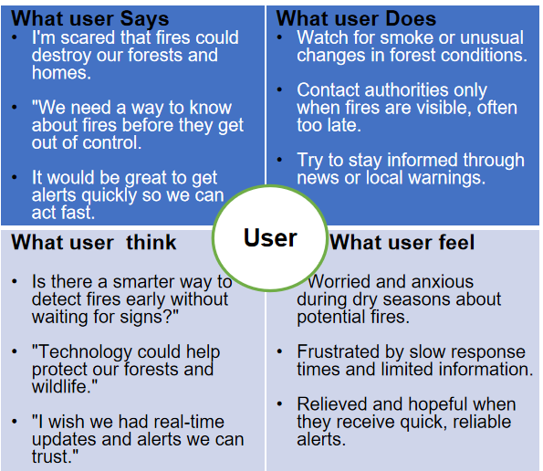

Sr. No. | Requirement | Proposed Solution
1 | Sensors | Use multiple sensors (temperature, smoke, flame, ) to collect real-time forest data.
2 | Data Transmission | Send sensor data wirelessly from Arduino Mega WiFi to AWS IoT Core using MQTT protocol.
3 | Alerts | Send instant alerts via SNS and display local warnings on OLED screens for quick action.

